Up to 600 North Koreans “vanish” after China's forceful deportation back to North Korea

Fears grow for fate of escaped North Koreans embroiled in mass forced deportation back to authoritarian homeland
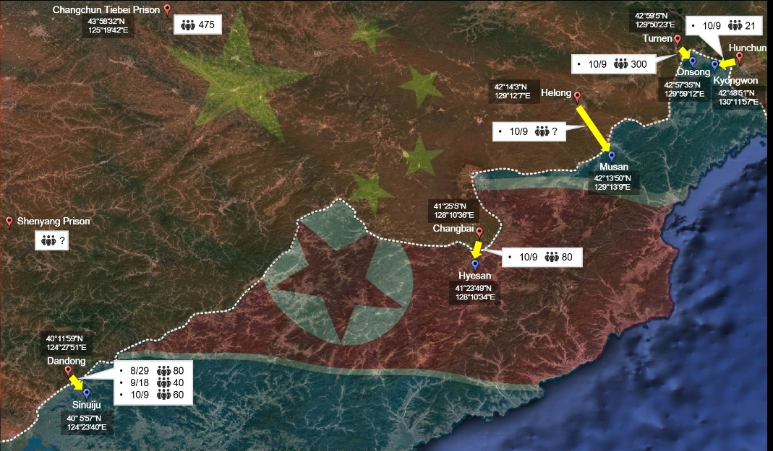

New map revealing border crossing points used in latest forced mass repatriation of North Korean defectors from China back to North Korea on 9 October 2023 and estimated number of defectors to have been transferred at each point. Source: TJWG

Highlights:

- Up to 600 North Koreans have “vanished” following a mass forced deportation event from China back to North Korea according to Seoul-based human rights organisation, the Transitional Justice Working Group [TJWG]
- TJWG reports that no communication has been established with the defectors since they were sent back nearly two months ago
- Torture, sexual and gender-based violence, imprisonment in concentration camps, forced abortions and execution await those forcibly returned in largest mass repatriation of its kind in years
- Buses and vans operated and heavily guarded by Chinese security officials seen transporting North Korean deportees from Chinese detention centres to North Korea at border crossings in October 2023
- TJWG reveals five border crossing points used by buses and vans carrying new deportees for the first time and also number of defectors crossing at each point
- Location and wellbeing of returned defectors remains unknown due to information blackhole in North Korea
- Identity of most of those forcibly deported also remains unknown, although most (70%+) expected to be women
- China and North Korean Governments neither confirm nor deny knowledge of the recent deportation
- Pressure mounts on UK, US, and other governments at TJWG hosted event today at the Assembly of States Parties to condemn China's recent forcible repatriation and to take action “to prevent many more North Koreans vanishing into the abyss”
- Sister of recently deported North Korean defector speaks out at event today and expresses anguish over fate of her sister: “My sister's only crime was being born in North Korea... All I want is for her to live in safety”
- Mounting concerns for thousands of North Korean defectors “sitting ducks” held in detention centres across China who could be deported and disappear “at any moment”

[London: 7 December 2023]: Today, Seoul-based human rights documentation NGO, the Transitional Justice Working Group [TJWG], has reported that up to 600 North Koreans have “vanished” following their forced deportation from China back to North Korea in October 2023 in the largest mass repatriation of its kind in years.

Fears have been growing for the fate of these defectors, who are mainly women, since they were forcibly deported back to North Korea nearly two months ago under the cover of darkness.

Those forcibly returned face the prospect of torture, sexual and gender-based violence, imprisonment in concentration camps, forced abortions and execution as their authoritative regime brands them “criminals” and “traitors.” Many were detained in China while trying to escape to South Korea and other countries in search of freedom.

The TJWG has reported that no communication has been established with the defectors since they were sent back. Neither the Chinese nor North Korean governments have released any information to confirm or deny the recent deportation, and the identity and current location of most of the defectors remains unknown due to the vast information blackhole that exists in North Korea.

Despite several sources in China reporting that hundreds of defectors were put on heavily guarded buses and vans and collected from their detention centres on 9 October 2023 and also TJWG's reliable sources obtaining and confirming video footage of the deportation, China has recently responded to concerns raised by Elizabeth Salmon, the UN special rapporteur on human rights in North Korea, and justified its longstanding policy of indiscriminate deportation of North Koreans. China maintains there is no clear evidence of torture or "massive human rights violations" in North Korea despite all major human rights organisations raising serious concerns about the country’s human rights record.

Today, the TJWG has revealed, through their open-source investigations and information gathered from reliable sources, five border crossing points in China's Jilin and Liaoning provinces used to deport the defectors back to North Korea. These include Dandong to Sinuiju, Changbai to Hyesan, Helong to Musan, Tumen to Onsong and Hunchun to Kyongwon. Through their investigations, the TJWG can also disclose the number of defectors estimated to have crossed each border point in the latest 9 October deportation, with the Onsong to Tumen crossing carrying 300 North Korean defectors.

This announcement comes as the TJWG is hosting an event today at the Assembly of States Parties of the International Criminal Court, which was created "to guarantee lasting respect for and the enforcement of international justice" in New York , in collaboration with international human rights law firm and foundation Global Rights Compliance, to urge the UK, US, and other governments to condemn China’s recent forcible deportation and its role in aiding and abetting of North Korea's gross human rights violations and to put pressure on China to end its policy of forcible repatriation.

Kim Cheol-ok is one of the few known North Koreans recently deported back to the country. She escaped North Korea at the age of 14, at the height of a catastrophic famine in 1998, and settled in a small town in the northeastern Chinese province of Jilin. She was forced into a marriage, which was set up by a human trafficker, with a Chinese man, and subsequently gave birth to a daughter. She came to love her family of 25 years, but was abruptly arrested and held incommunicado on 5 April 2023, just months before her granddaughter’s birth. Her sister will speak at the event today of her torment at the ominous fate awaiting Kim Cheol-ok in North Korea, who can no longer speak Korean.

TJWG fears that as many as 1,500 more North Korean defectors could be deported back to North Korea in the coming months since Pyongyang announced the reopening of its borders in August.

Ethan Hee-Seok Shin, Legal Analyst at TJWG commented: “Ethan Hee-Seok Shin, Legal Analyst at TJWG commented: “The international silence shrouding the human rights atrocities against the North Korean people must stop. With the Assembly of States Parties underway, we urge the UK and US governments to condemn and take actions against China's recent forcible repatriation to prevent many more North Koreans vanishing into the abyss on their forced return to their homeland. We estimate that at least 1,100 more North Koreans are estimated to be held in Chinese detention centres; they are “sitting ducks” who could be deported back to the murderous regime which they fled from at any moment.”
“The international community must work together to not only ensure both China and North Korea are held accountable for their atrocious actions, but also find a solution to this generational issue. I call upon UN Secretary-General António Guterres, UN High Commissioner for Refugees Filippo Grandi and High Commissioner for Human Rights Volker Türk to provide good office to negotiate an acceptable solution and end the needless suffering of North Korean defectors.”
Catriona Murdoch, British Barrister and Partner at Global Rights Compliance added: “Crimes of enforced disappearance torment and plague the families left behind. The utter anguish of a life trapped in a Chinese detention centre faced with a forcible repatriation to the dystopic North Korea where they will most likely endure a barbaric fate as punishment for their escape. With the international gaze fixed on finding those kidnapped in Gaza, or forcibly transferred into Russia, once again the systematic human rights abuses and international crimes occurring inside North Korea continue unabated and unacknowledged. The time has come to speak out, search for the missing, prevent further disappearances and rigorously pursue accountability for those perpetrating such crimes.”
-ENDS-

For further information, and interview opportunities, please contact:
Harriet Shearer / Harvey Presence / Will Heron
The Communication Group plc
020 7630 1411
tjwg@thecommunicationgroup.co.uk

Press release issued on behalf of Transitional Justice Working Group

*Notes to Editors:

Transitional Justice Working Group
TJWG is a human rights documentation NGO established in Seoul in 2014 by human rights activists and researchers from five countries (South Korea, North Korea, the United States, the United Kingdom and Canada). The organisation aims to develop the best practice to address mass human rights violations and to realise a victim-oriented approach and justice in societies that are making a transition from or have yet to make a transition from armed conflict or dictatorship. TJWG is a leading organisation in documenting and mapping human rights violations in countries with limited physical access, such as North Korea.

Ethan Hee-Seok Shin
Ethan Hee-Seok Shin is a legal analyst at Seoul-based human rights documentation NGO Transitional Justice Working Group (TJWG). He has interviewed North Korean escapees who make their way to South Korea through China to record enforced disappearances and other grave human rights violations, made submissions to the UN human rights experts on their behalf, and set up FOOTPRINTS, an online database of the people taken by North Korea. He is an advocate for ending China's policy of indiscriminate refoulement for the North Korean escapees, many of whom should be protected as refugees under international law, and has helped raised the issue recently at the UN Committee on the Elimination of Discrimination against Women (CEDAW). He holds a Ph.D. in international law from Yonsei University in South Korea and an LL.M. from Harvard Law School.

Global Rights Compliance
Global Rights Compliance (GRC) is an international human rights law firm and foundation, achieving justice through the innovative application of international law. A key strand of GRC’s mission is to bring accountability for human rights violations and advocate for the improvement of such rights. Since 2020, GRC’s DPRK team have been involved in the implementation of projects seeking to pursue justice, accountability, and improvement of human rights in the DPRK, working closely with North Korean Human Rights CSOs and organisations such as TJWG.

North Korean Defectors
Since the mass famine in the 1990s, hundreds of thousands of North Koreans have risked their lives to escape the totalitarian regime. Accounting for more than 70%, defectors are disproportionately women. Despite DPRK propaganda portraying North Korean women having equal opportunities and status as men, North Korean women are treated as second-class citizens in the country, prompting the decision by many to flee the country, often to China.

Many who attempt to flee North Korea are trafficked and sold whilst on the road to freedom. For those who make it to China, their fate can be even more bleak. North Korean escapees should be regarded as refugees, but China circumvents its legal obligations. Instead of granting ​​those who make it to China from North Korea ​​refugee status and the protections this should entail, China treats them as illegal “economic migrants.” China is ranked in the lowest bracket of the recent US State Department’s 2023 Trafficking In Persons report.

https://www.bbc.co.uk/news/world-asia-67098453
https://lt.usembassy.gov/wp-content/uploads/sites/184/Trafficking-in-Persons-Report-2023.pdf

